AI ASSISTED CODING

**LAB TEST-1**

NAME: Baggi Praneeth

HT NO: 2403A51246

Batch No: 11

## Question 1:

### Write a python code to calculate the sum of odd and even numbers in a given list using zero shot promt.

**Prompt:**

Write a Python function that calculates and prints the sum of odd and even numbers in a given list.

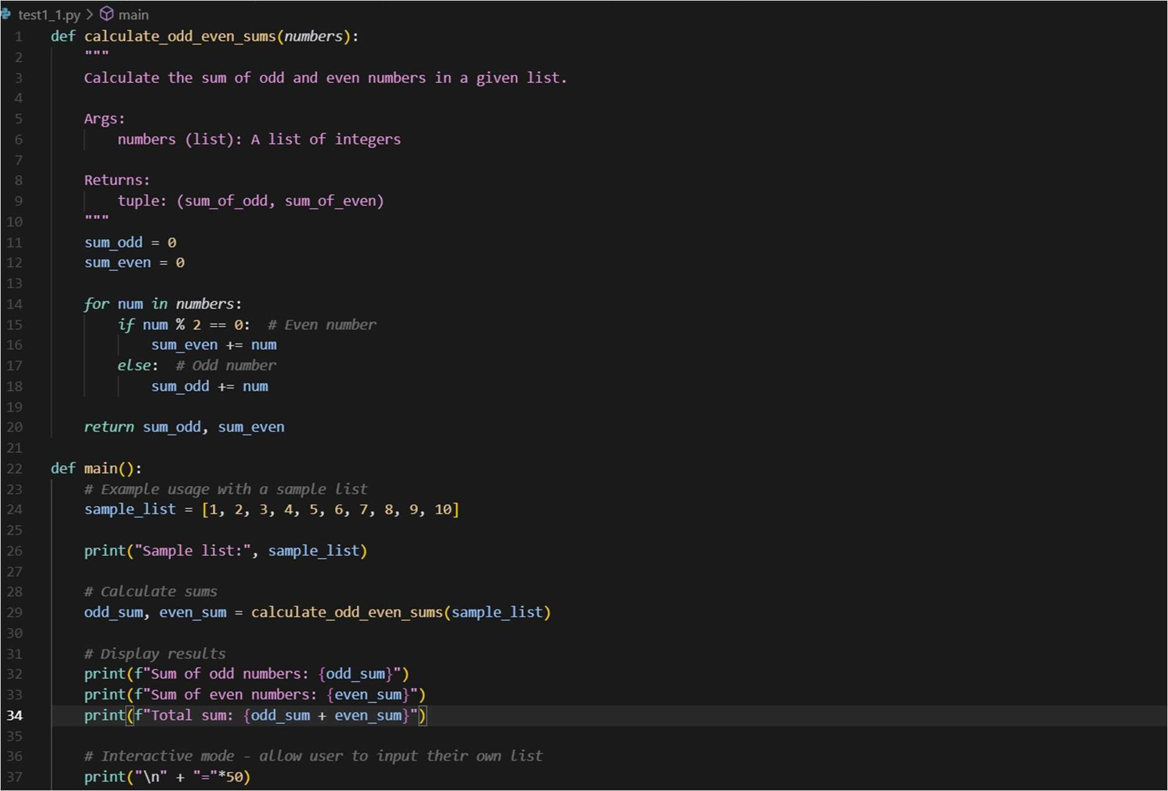

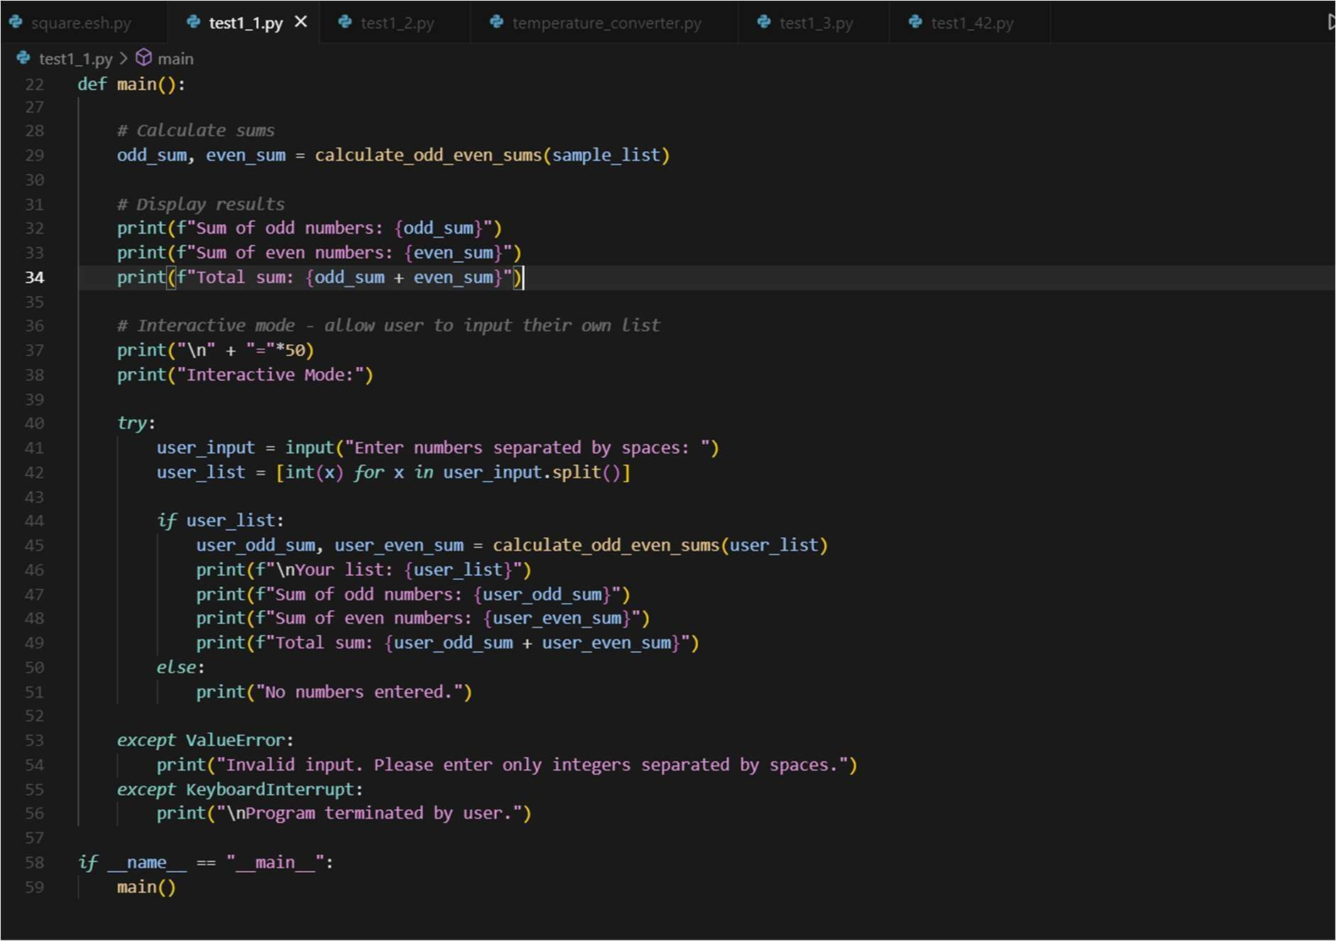

# OUTPUT:

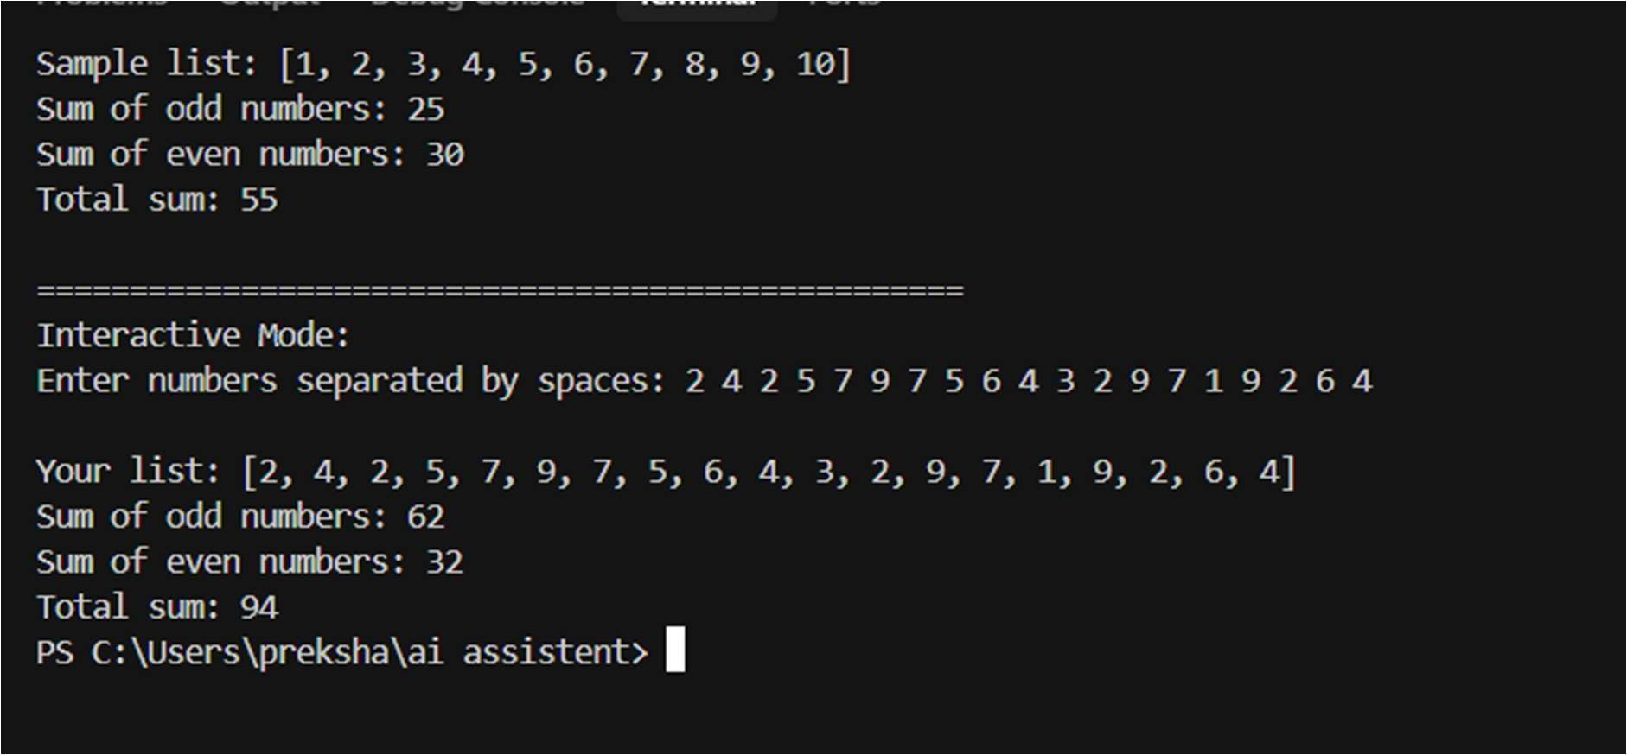

## Question 2:

### write a python code for a given list of integers, remove duplicates and print the sorted result use one shot promting.

**Promt:** Given a list of integers, remove duplicates and print the sorted result.

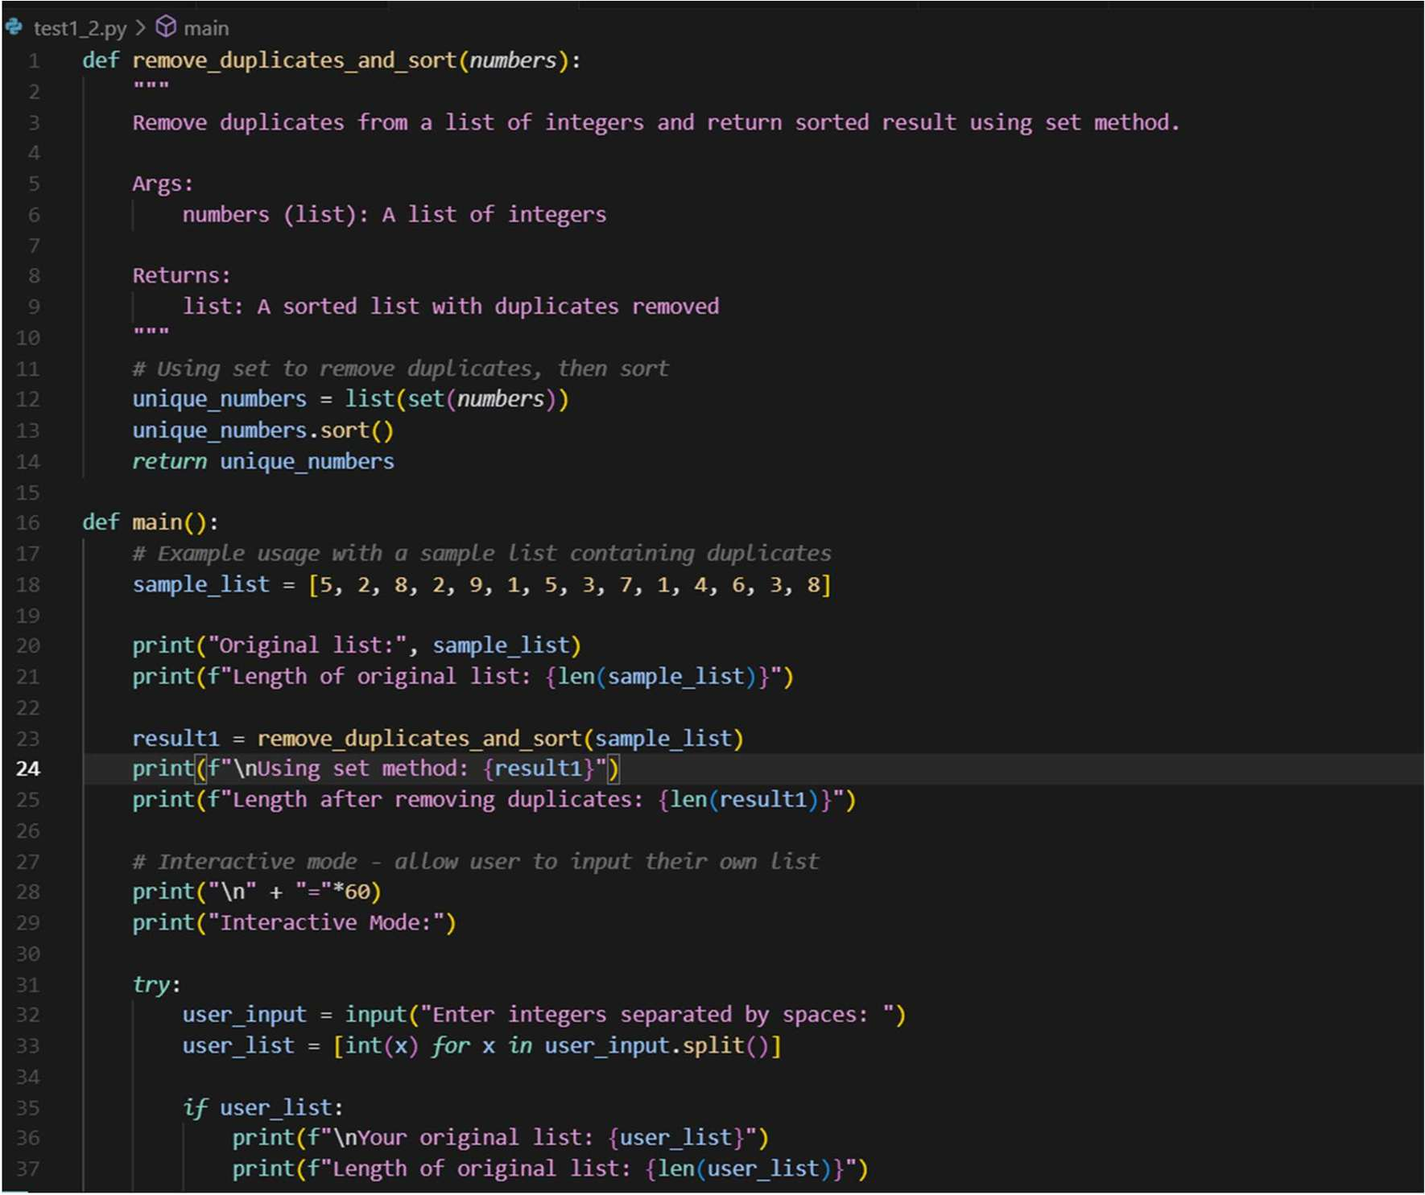

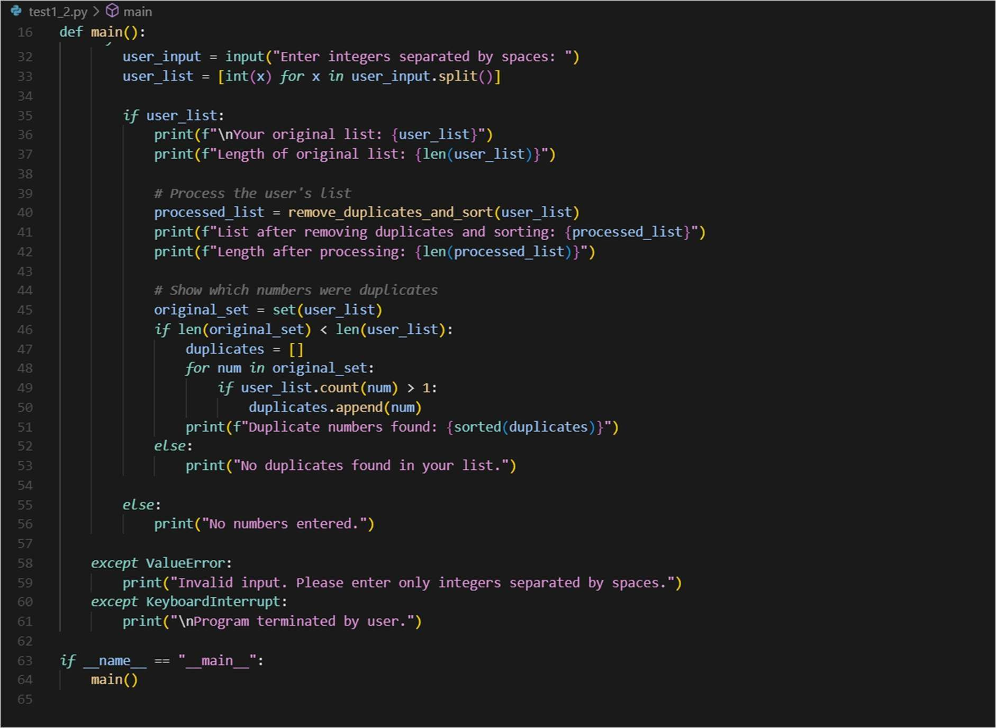

## Output:

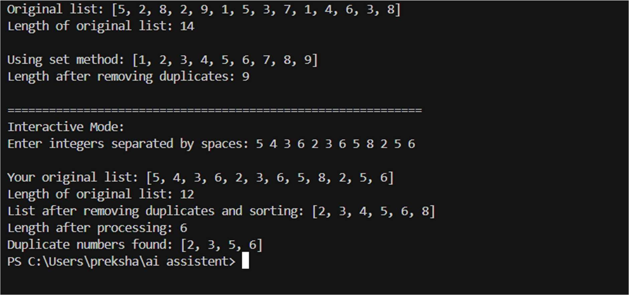

**Question 3:**

write a python function that converts the temperture between celsius, fahrenheit and kalvin based on user choice.Use few shot promiting**.**

**Prompt**: Write a Python function that converts temperature between Celsius, Fahrenheit, and Kelvin based on user choice.

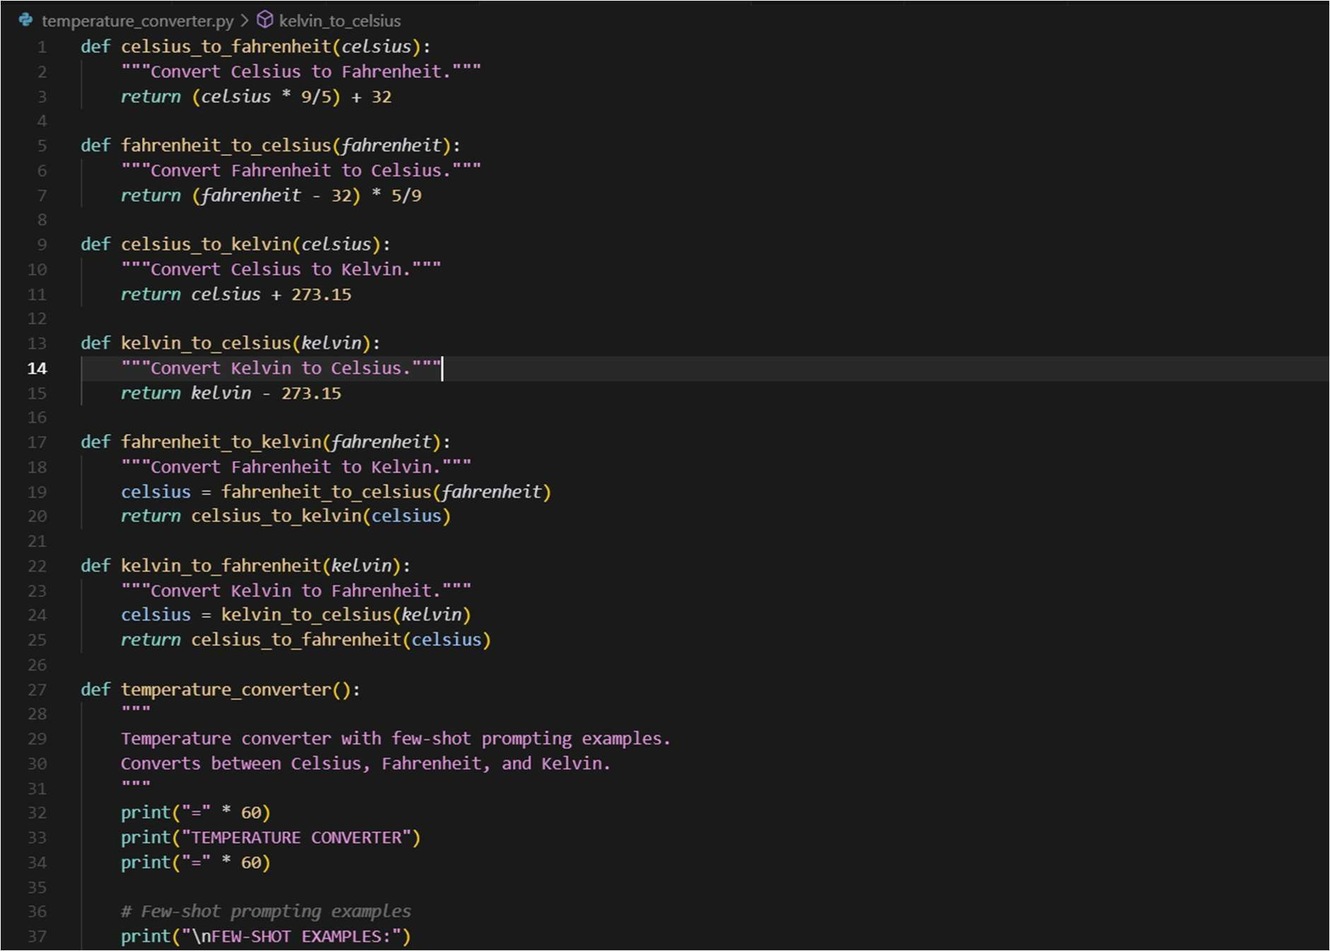

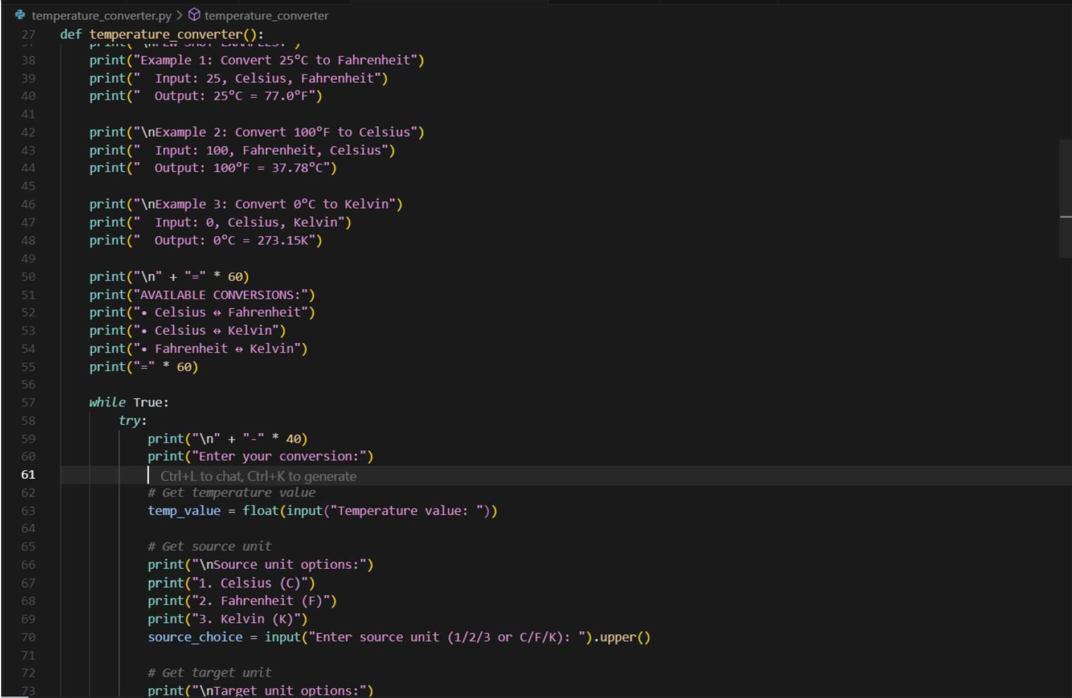

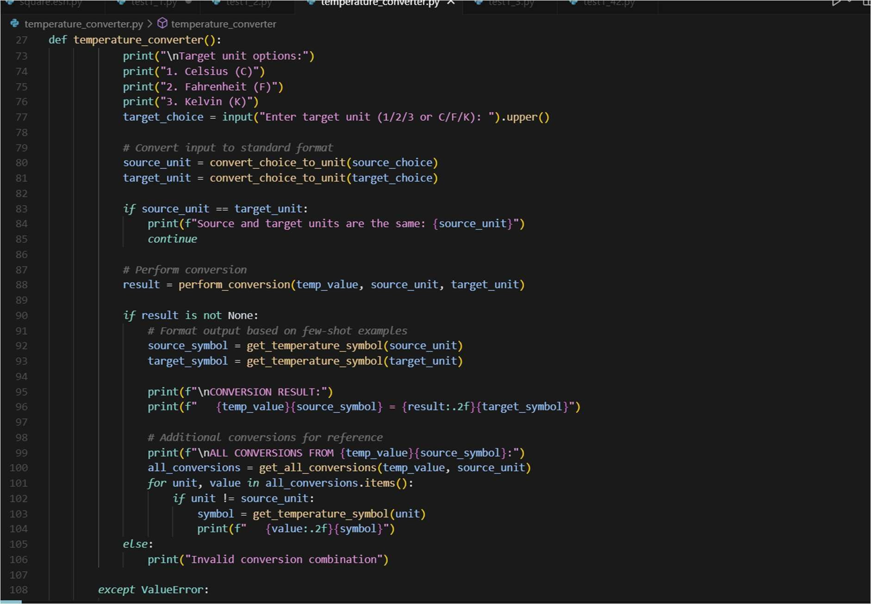

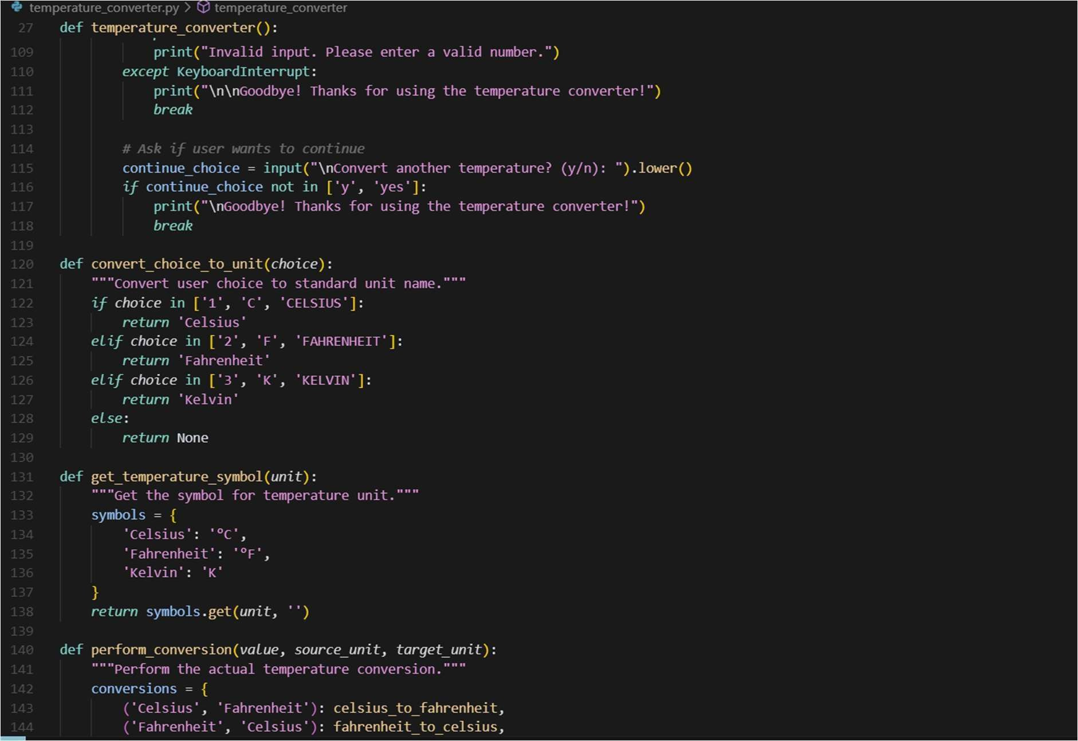

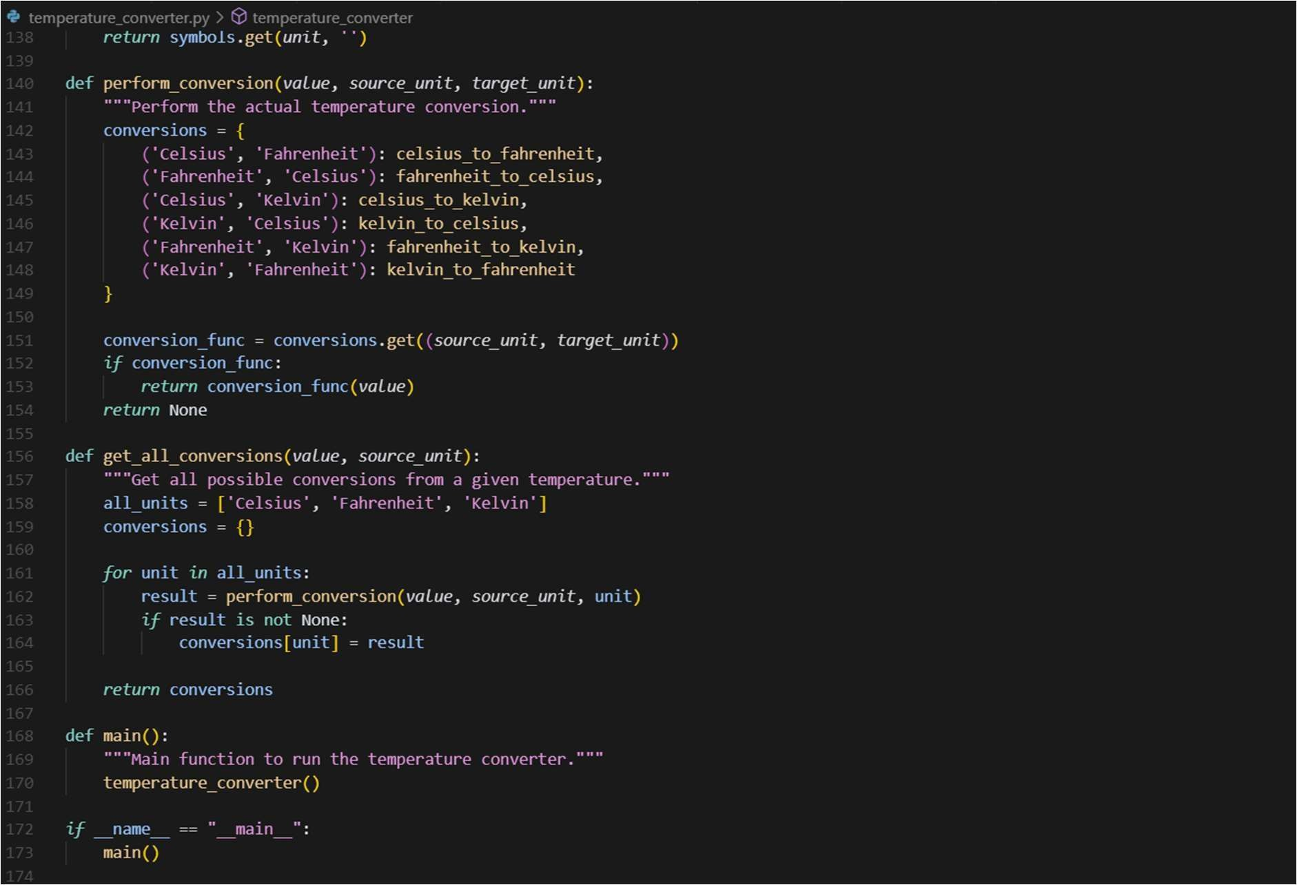

# OUTPUT:

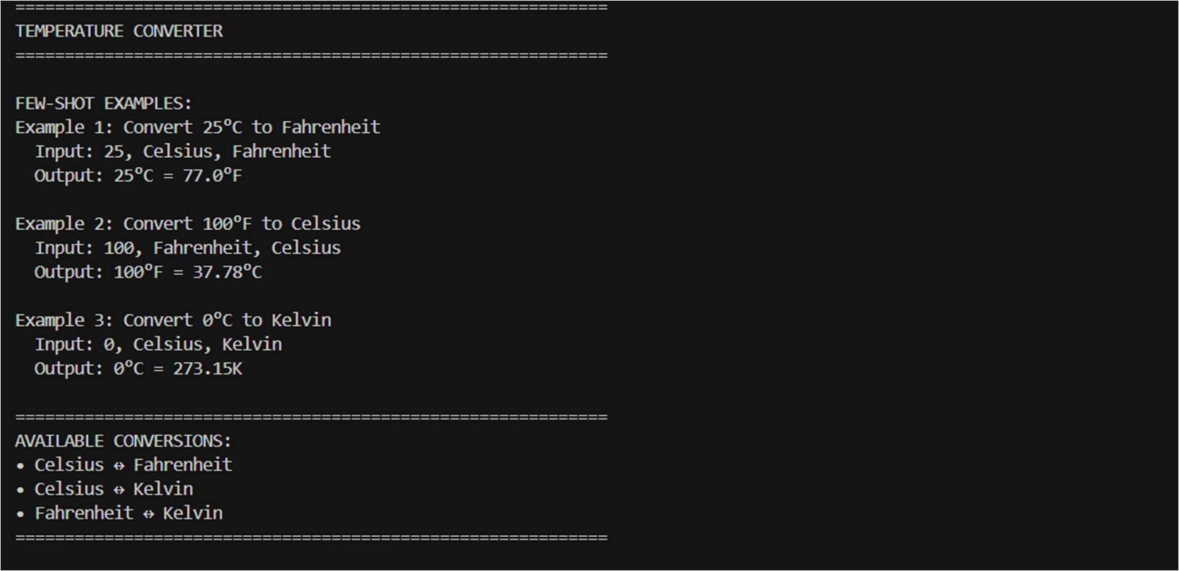

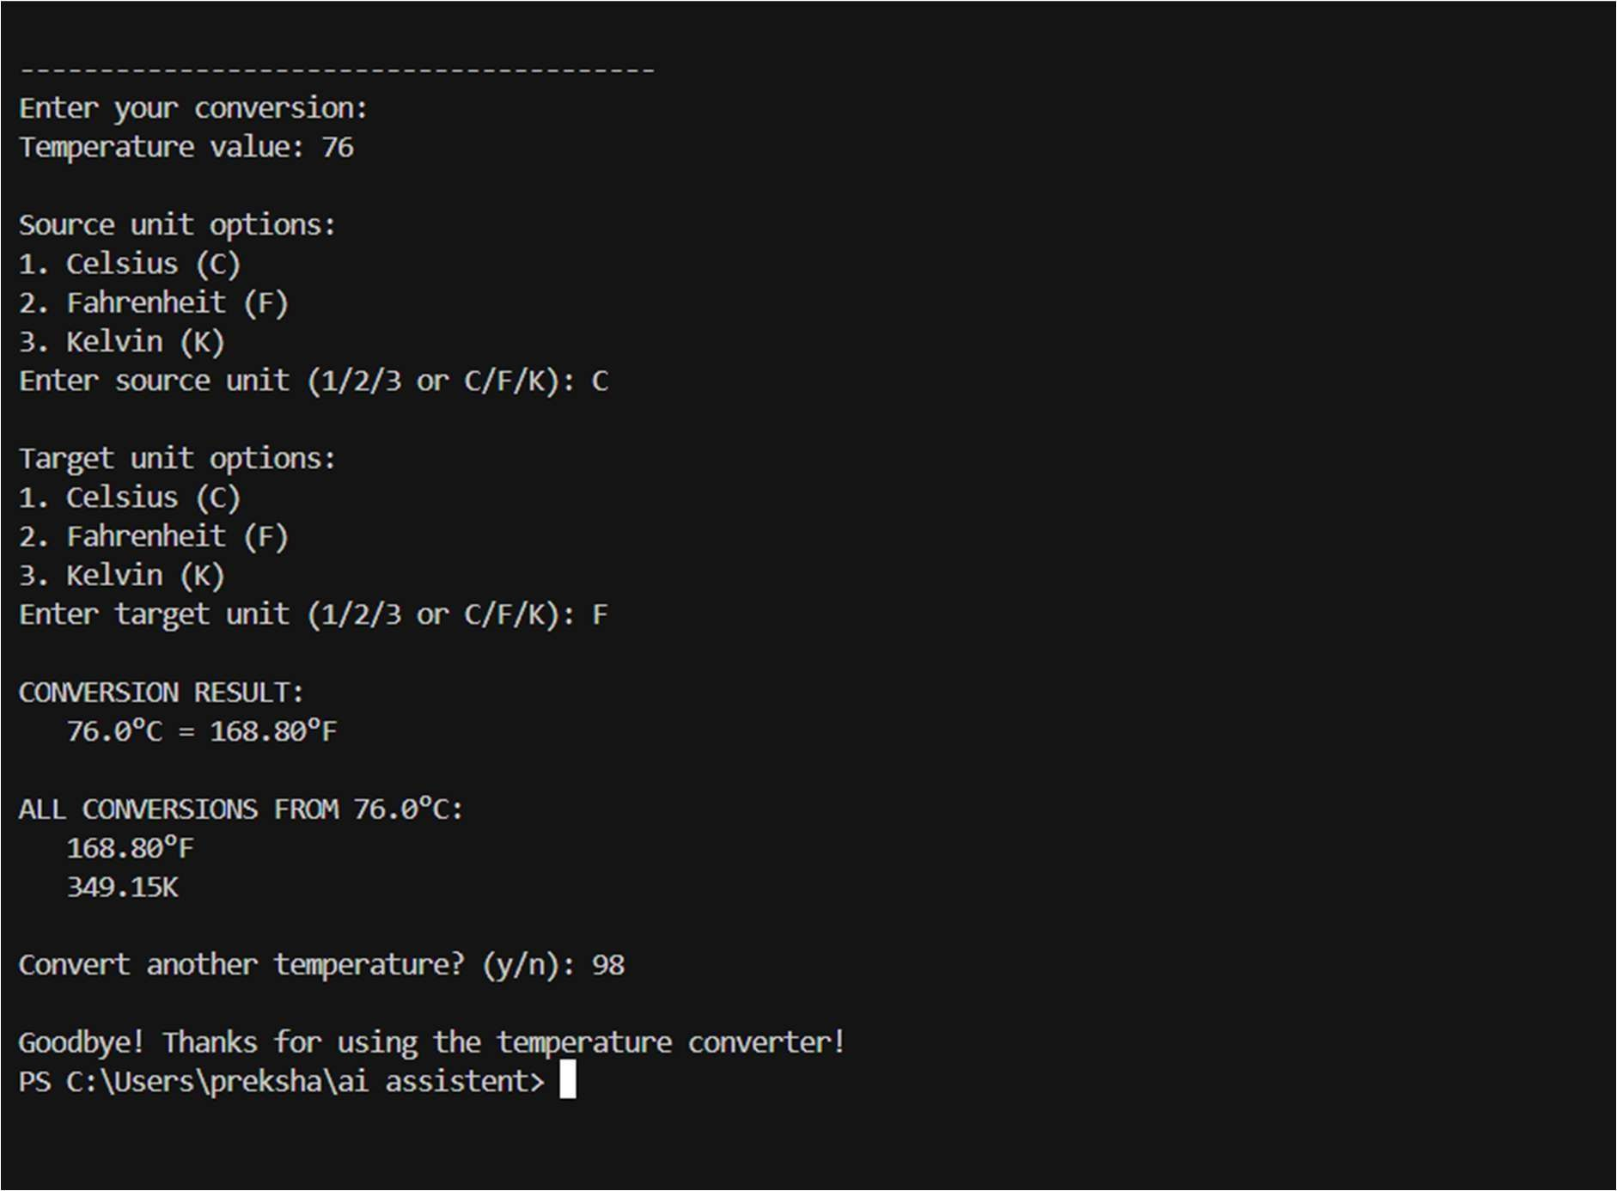

## Question 4:

Write a python function to remove the punctuaion,convert to lowercase, and remove stop words from a given text use zero shot promting.

**Prompt:** Write a Python function that takes a string, removes punctuation, converts it to lowercase, and removes stop words.

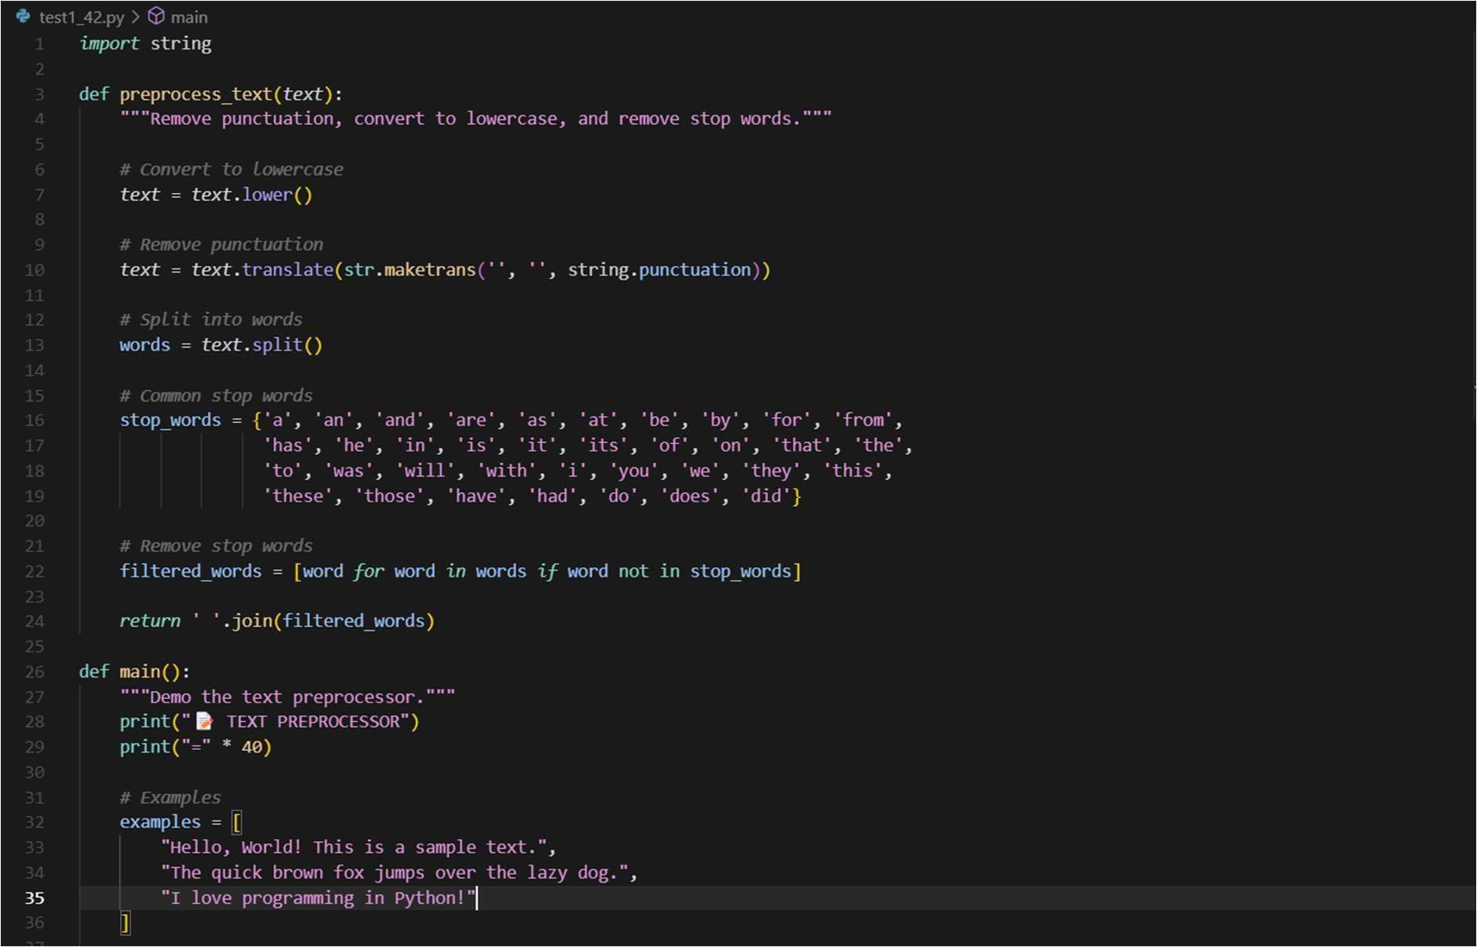

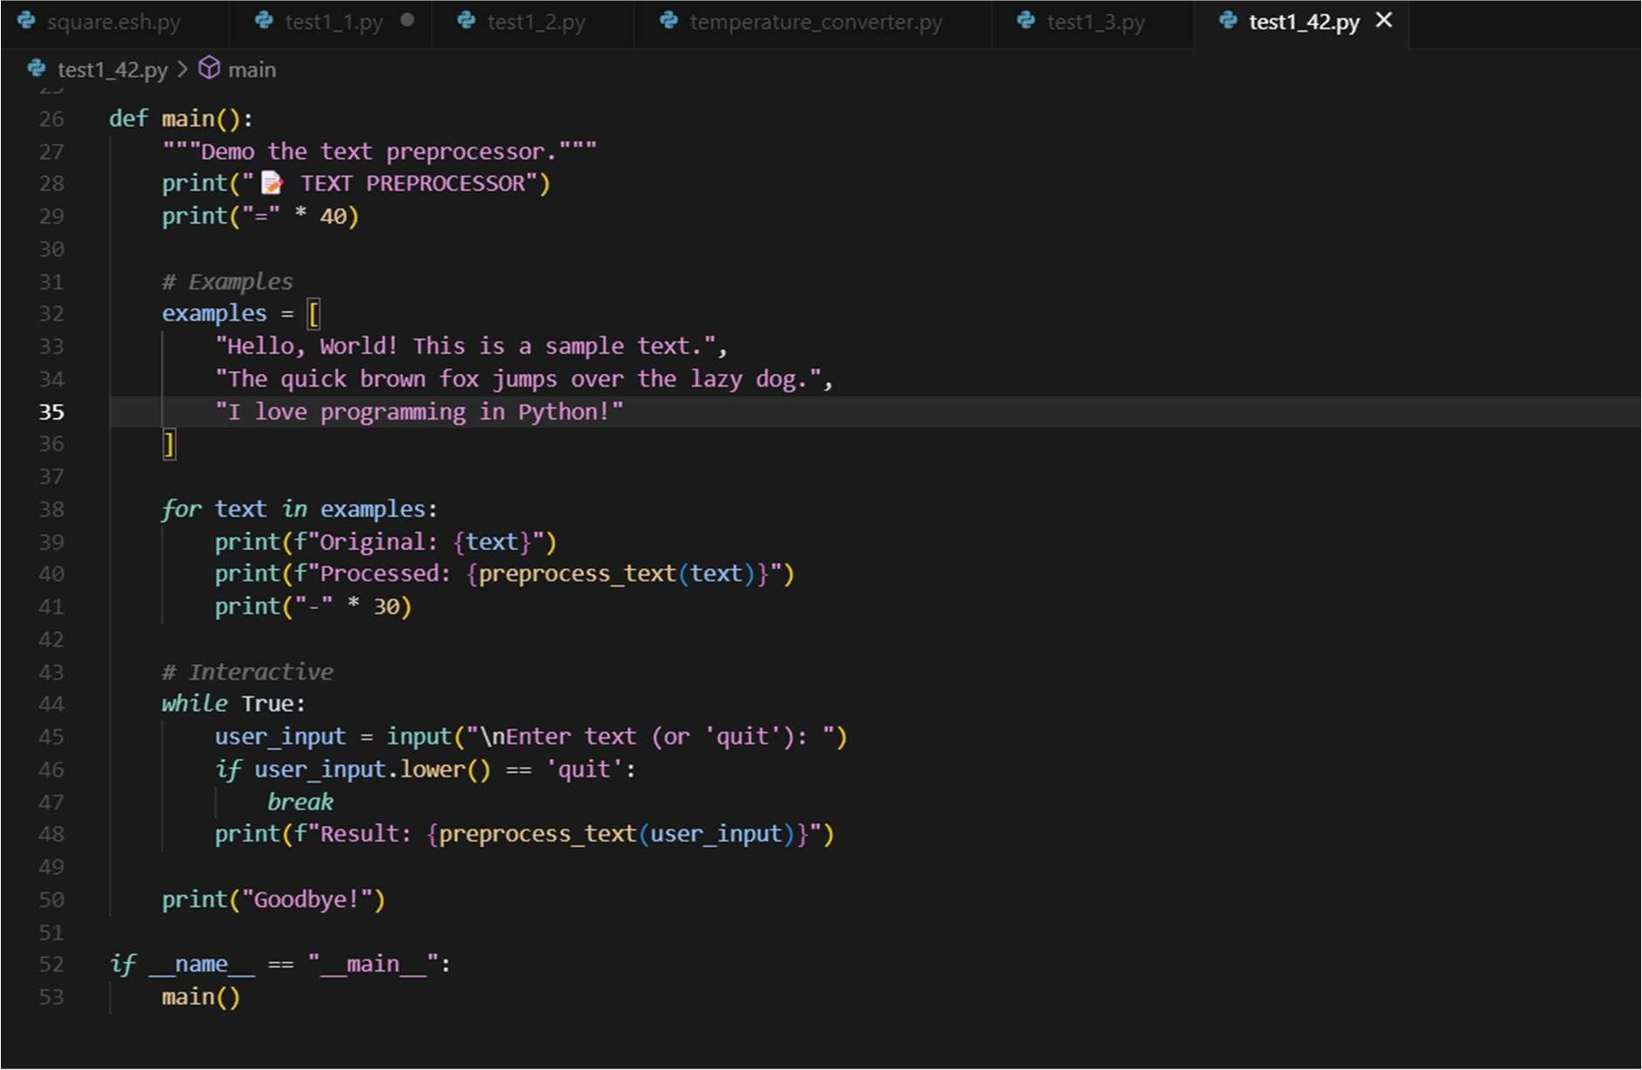

**OUTPUT:**

